Sr. No. | Name of the deductor | TAN of the deductor | Section under  which deduction  made | Date of Payment/  Credit | Amount paid/  credited  Rs. | Tax deducted  (TDS +  Surcharge +  Education Cess)  Rs. | TDS  deposited  Rs.
(501) | (502) | (503) | (504) | (505) | (506) | (507) | (508)

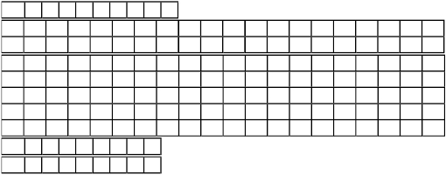
FORM NO. 26AS
(See section 203AA and second proviso to section 206C(5) and rule 31AB)

Annual Tax Statement under section 203AA

Permanent Account Number :
Name of the assessee :

Address of the assessee :

Financial year :
Assessment year

PAN: Financial year: Assessment year:

PART A
Details of tax deducted at source :
Sr. No. | Name of the seller | TAN of the seller | Section under  which deduction  made | Date on which  amount paid/  debited | Amount paid/ debited  Rs. | Amount of tax  collected (TCS +  Surcharge +  Education Cess)  Rs. | TCS  deposited  Rs.
(509) | (510) | (511) | (512) | (513) | (514) | (515) | (516)
 | Total
Sr.  No. | Major  Head  code | Minor  Head  code | Tax  Rs. | Surcharge  Rs. | Education  Cess  Rs. | Interest  Rs. | Others  Rs. | Total Tax  Rs. | BSR code | Date on which  tax deposited | Challan  Serial No.  Rs.
(517) | (518) | (519) | (520) | (521) | (522) | (523) | (524) | (525) | (526) | (527) | (528)
Total

PART B

Details of tax collected at source:

PAN: Financial year: Assessment year:

PART C
Details of tax paid (other than TDS or TCS):

Total

Date: ___________
This statement is issued on behalf of the Income-tax Department. The details of tax indicated above are based on the data submitted by
deductors/sellers and confirmation from banks that the taxes have been received.
This statement does not include payments pertaining to assessment year other than mentioned above, and payments against penalties.

